# INTRODUCTION

* 1. Overview

The adaptability level of students in online education refers to their ability to adjust to the new learning environment and successfully complete their courses. It is influenced by a number of factors, including their individual learning style, motivation, self-regulation, and access to technology. Students who are more adaptable to online learning are typically those who are self-directed and motivated. They are able to set their own learning goals, manage their time effectively, and stay on track without the need for constant supervision. They are also able to learn independently and work well without the social interaction of a traditional classroom setting.

* 1. Purpose

The adaptability level of students is important for a number of reasons. First, it can help students to succeed in online education. As mentioned earlier, online learning requires more self-discipline and motivation than traditional classroom learning. Students who are more adaptable to online learning are more likely to be able to manage their time effectively, set realistic expectations, and build a strong support network. Second, the adaptability level of students can help them to succeed in the workplace. The workplace is constantly changing, and employees who are adaptable are more likely to be able to keep up with the changes. They are also more likely to be able to learn new skills and take on new challenges. Third, the adaptability level of students can help them to be successful in life. In today's world, it is important to be able to adapt to change. Students who are adaptable are more likely to be able to handle the challenges that they face in life and to achieve their goals.

# LITERATURE SURVEY

* 1. Existing problem

The COVID-19 pandemic has forced many high school students to transition to online learning. This has been a challenge for many students, as online learning requires different skills and resources than traditional classroom learning.

Some of the existing problems on adaptability and high school students' online learning during COVID-19 include:

* Lack of access to technology: Not all students have access to a computer or internet connection at home. This can make it difficult for them to participate in online learning.
* Lack of support: Some students may not have the support they need from their family or friends to succeed in online learning. This could include help with technology, motivation, or time management.
* Distractions at home: It can be difficult for students to focus on their studies when there are distractions at home, such as siblings, pets, or household chores.
* Lack of social interaction: Online learning can be isolating for students, as they miss out on the social interaction that they would get in a traditional classroom setting. This can lead to feelings of loneliness and anxiety.
* Academic challenges: Online learning can be more challenging for some students than traditional classroom learning. This is because they may have difficulty understanding the material, managing their time, or staying motivated.

These are just some of the existing problems on adaptability and high school students' online learning during COVID-19. There are a number of things that can be done to address these problems, such as providing students with access to technology, support, and resources. Educators can also design online learning courses that are engaging and interactive, and that provide opportunities for social interaction.

* 1. Proposed solution

Cognitive engagement, affective engagement, and behavioral engagement are three important factors that contribute to student success in online education.

* Cognitive engagement refers to the mental effort that students put into learning. This includes activities such as reading, thinking about the material, and solving problems. Cognitive engagement is essential for students to understand and remember the information they are learning.
* Affective engagement refers to the emotional connection that students have with the learning material. This includes feelings such as interest, excitement, and motivation. Affective engagement can help students stay motivated and engaged in their studies.
* Behavioral engagement refers to the actions that students take to participate in the learning process. This includes activities such as attending class, completing assignments, and interacting with classmates and instructors. Behavioral engagement is important for students to demonstrate their understanding of the material and to receive feedback on their progress.

Student adaptability is also an important factor in online education. Adaptability refers to the ability to adjust to new situations and challenges. Students who are adaptable are more likely to succeed in online education, which can be a different learning environment than traditional face-to-face instruction.

# THEORITICAL ANALYSIS

* 1. Block diagram

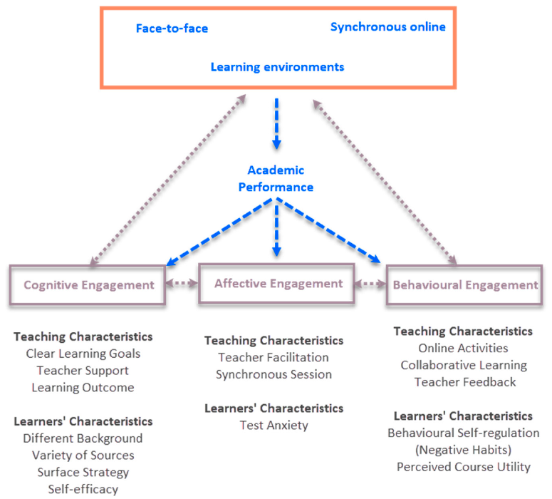

* 1. Hardware / Software designing

Hardware Specification Processor : Intel(R) Pentium(R)

CPU 3825U @ 1.90GHz RAM : 4 GB

System Type : 64-bit operating system

Operating System : Windows 10

Tools : IBM COGNOS, Google Colaboratory, Excel

# EXPERIMENTAL INVESTIGATIONS

In addition to these interventions, there are a number of things that instructors can do to promote student adaptability in online education. These include:

* Providing clear and concise instructions.
* Using active learning strategies.
* Providing opportunities for students to collaborate with each other.
* Offering regular feedback.
* Being supportive and encouraging.

# FLOWCHART

# 

# Data collection, exploration, splitting, training, testing, analysis, and interpretation are the six stages of the machine learning process. Data collection is the process of gathering data from a variety of sources. This can be done through surveys, interviews, experiments, or by collecting existing data from databases. Data exploration is the process of understanding the data by summarizing its main characteristics and identifying any patterns or trends. This can be done using statistical methods, data visualization, or machine learning .Data splitting is the process of dividing the data into two sets: a training set and a test set. The training set is used to train the machine learning model, and the test set is used to evaluate the performance of the model. Training is the process of fitting a machine learning model to the training data. This is done by adjusting the parameters of the model until it minimizes a loss function. Testing is the process of evaluating the performance of a machine learning model on the test set. This is done by measuring the accuracy, precision, recall, and F1 score of the model. Analysis is the process of interpreting the results of the machine learning model. This involves understanding how the model works and how it can be used to make predictions. Interpretation is the process of explaining the meaning of the results of the data analysis. This involves drawing conclusions and making recommendations based on the data. The six stages of the machine learning process are often iterative, meaning that they may be repeated as needed. For example, the results of the data analysis may lead to the need to collect additional data or to refine the machine learning model.

# RESULT

# Dataset

# 

# Adaptability level for males and females

# 

# Adaptability levels for different age groups

# 

# Adaptability for college,shools

# 

# ADVANTAGES & DISADVANTAGES

# The adaptability of students to online education can be both an advantage and

# a disadvantage.

# Advantages

# Flexibility: Online education can be more flexible than traditional face-to-face learning, as students can access lectures and materials at their own pace and time. This can be beneficial for students with busy schedules or who live in remote areas.

# Self-paced learning: Online education can also allow students to learn at their own pace, which can be helpful for students who learn differently or need more time to master a concept.

# Access to resources: Online education can provide students with access to a wider range of resources than traditional face-to-face learning, such as online libraries, discussion forums, and tutoring.

# Cost-effectiveness: Online education can be more cost-effective than traditional face-to-face learning, as students do not have to travel to a physical campus or pay for textbooks.

# Disadvantages

# Lack of social interaction: Online education can lack the social interaction that is present in traditional face-to-face learning. This can be a challenge for students who learn best by interacting with others.

# Technical difficulties: Online education can be disrupted by technical difficulties, such as internet outages or software problems. This can be frustrating for students and can make it difficult to learn.

# Self-discipline: Online education requires a high degree of self-discipline, as students are responsible for managing their own time and learning. This can be a challenge for some students.

# Isolation: Online education can lead to feelings of isolation, as students may not have the same opportunities to interact with their peers and teachers as they do in traditional face-to-face learning.

# Overall, the adaptability of students to online education is a complex issue with both advantages and disadvantages. The best way to determine whether online education is a good fit for a particular student is to consider their individual needs and preferences.

# APPLICATIONS

# Adaptive learning platforms: These platforms use artificial intelligence to personalize the learning experience for each student. This can help students learn at their own pace and focus on the areas where they need the most help.

# Learning analytics: This is the process of collecting and analyzing data about student learning. This data can be used to identify students who are struggling and provide them with additional support.

# Student engagement tools: These tools can help students stay motivated and engaged in their learning. This can include things like discussion forums, peer tutoring, and gamification.

# CONCLUSION

# In conclusion, student adaptability is an important factor in online education success. Students who are able to adapt to the self-directed, asynchronous environment of online learning are more likely to succeed. There are a number of factors that can affect student adaptability, including technological skills, self-management skills, learning style, and motivation. Online learning providers can help to improve student adaptability by providing the right tools and support, such as adaptive learning platforms, learning analytics, student engagement tools, and support services. By following the tips outlined above, online learning providers can create a learning environment that is conducive to student success.

# FUTURE SCOPE

The future scope of student adaptability in online education is promising. As the demand for online learning continues to grow, so will the need for adaptable learners. Online learning providers are constantly developing new tools and support services to help students adapt to the online environment. These tools and services will make it easier for students to learn independently, manage their time effectively, and stay motivated. Enhancements that can be made in the future.

# BIBILOGRAPHY

References of previous works or websites visited/books referred for analysis about the project, solution previous findings etc.

# APPENDIX

A. Source Code

Attach the code for the solution built.